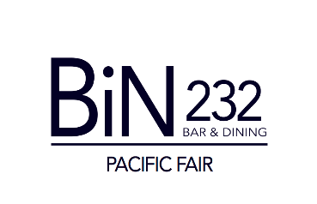

Beer

Draught 330ml
bin lager 7.5
stone & wood pacific ale 9
peroni nastro azzuro 9

Bottled
coopers light 6.5
tooheys extra dry 6.5

balter xpa 9

balter captain sensible (mid strength) 8

asahi 9

peroni leggera (mid strength) 8

peroni red 8.5

corona 8
4 pines nitro stout 9
pilsner urquell 9

Cider
strongbow apple or pear cider 8.5

Cocktails
Lavender Blush
ink gin, st germain elderflower, lime juice, sugar 18

Mojito – Passionfruit or Lychee
bacardi, passionfruit or lychees, mint, lime & soda 18

Espresso Martini
vodka, kahlua, white crème de cacao, fresh espresso 18

Patron Margarita
patron silver, cointreau, lime 19

Aperol Spritz
aperol, sparkling wine, orange & soda 18

Aqua Marina
raspberry vodka, malibu, blue curacao, cranberry,
pineapple & apple 18

Old Fashioned
woodford reserve bourbon, raw sugar, orange rind & bitters 18

Wine
Sparkling Glass 120ml Bottle
nv azahara, brut, south australia 7.5 37

nv louis bouillot, grande reserve, france 12 62

Champagne

nv g.h. mumm, france 100

nv louis roederer brut, france 125

nv pol roger brut, france 130

White Glass 150ml Bottle
2019 black sheep, sauvignon blanc, south australia 7.5 35

2018 opawa, sauvignon blanc, marlborough, nz 11 54

2018 west cape howe, chardonnay, western australia 7.5 37

2018 vasse felix, filius, chardonnay, western australia 12 57

2017 heggies, chardonnay, eden valley 58

2018 chaffey bros, not your grandma’s riesling, eden valley 10.5 50

2019 redbank, pinot grigio, victoria 7.5 36

2018 vavasour, pinot gris, marlborough, nz 9.5 48

2020 deakin estate, moscato, victoria 8 38

Rose
2019 la vieille ferme, rose, orange, france 9 42

Red
2020 deakin estate, merlot, victoria 7.5 36

2017 opawa, pinot noir, marlborough, nz 13 60

2018 mesta, tempranillo, spain (organic) 8 38

2018 jim barry, the atherley, shiraz, clare valley 9.5 46

2018 chaffey bros, synonymous, shiraz, barossa 11 54

2017 torbreck, juvenile, GSM, barossa 12 56

2017 hesketh, twist of fate, cab sauv, south australia 8 38

2018 finca las moras, malbec, san juan, argentina 8 40

*a selection of soft drinks, juices and coffees available also.

